**Case Study of Various System Buses like PCI, ISA, USB**

**THEORY:**

**INTRODUCTION TO SYSTEM BUSES:**

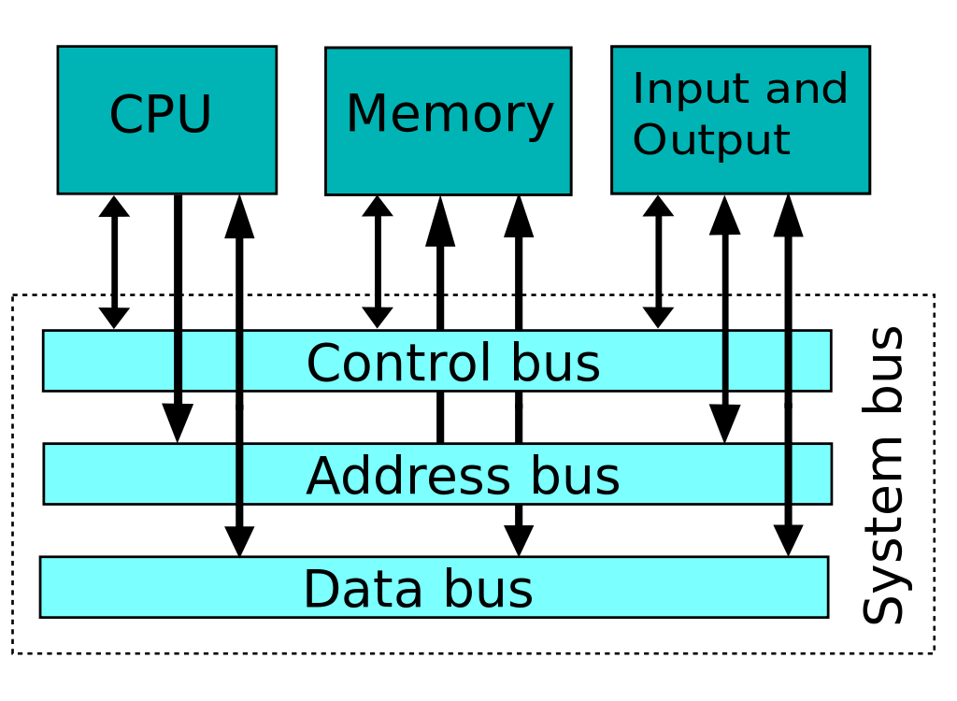

FIGURE 1: System bus block diagram

A system bus is a single [computer bus](https://en.wikipedia.org/wiki/Bus_(computing)) that connects the major components of a computer system, combining the functions of a [data bus](https://en.wikipedia.org/wiki/Memory_bus) to carry information, an [address bus](https://en.wikipedia.org/wiki/Address_bus) to determine where it should be sent, and a [control bus](https://en.wikipedia.org/wiki/Control_bus) to determine its operation. The technique was developed to reduce costs and improve modularity, and although popular in the 1970s and 1980s, more modern computers use a variety of separate buses adapted to more specific needs.

**PRIME FEATURES:**

1. The control bus carries the control, timing and coordination signals to manage the various functions across the system.
2. The address bus is used to specify memory locations for the data being transferred.
3. The data bus, which is a bidirectional path, carries the actual data between the processor, the memory and the peripherals.

**VARIOUS BUSES:**

* ISA(INDUSTRY STANDARD ARCHITECTURE) in 1981
* PCI(PERIPHERAL COMPONENT INTERCONNECT) in 1992
* USB(UNIVERSAL SERIAL BUS) in 1996

**ISA(INDUSTRY STANDARD ARCHITECTURE):**

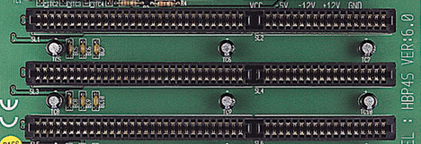

FIGURE 2: INDUSTRY STANDARD ARCHITECTURE

**INTRODUCTION:**

ISA(Industry Standard Architecture) is standard [bus](https://searchstorage.techtarget.com/definition/bus) (computer interconnection) [architecture](https://whatis.techtarget.com/definition/architecture) that is associated with the IBM AT motherboard. It allows 16 bits at a time to flow between the motherboard circuitry and an expansion slot card and its associated device(s). Originally referred to as the PC/AT-bus, it was also termed I/O Channel by IBM. The ISA term was coined as a [retronym](https://en.wikipedia.org/wiki/Retronym" \o "Retronym) by competing PC-clone manufacturers in the late 1980s or early 1990s as a reaction to IBM attempts to replace the AT-bus with its new and incompatible [Micro Channel architecture](https://en.wikipedia.org/wiki/Micro_Channel_architecture).

Advantages
â¢ Low cost
â¢ Compatibility
â¢ Used widely
Disadvantages
â¢ Low speed
â¢ Jumpers and DIP switches
â¢ Becoming out-da...

FIGURE 3: ISA BLOCK DIAGRAM

**CHARACTERISTICS:**

1. 16-bit characteristics. It supported 16-bit peripheral devices
2. Five devices with 16-bit interrupt request (IRQ) could be connected at the same time.
3. Also, three additional devices could be connected parallel to five devices with 16-bit IRQ.
4. 16-bit direct memory access (DMA) channel.
5. The CPU clock speed varied from 16 to 20 MHz.

* **ADVANTAGES:**
* Low cost.
* Compatibility.
* Used widely.
* **DISADVANTAGES:**
* It had low speed.
* It had Jumpers and DIP switches.
* It was becoming out-dated.

**PCI(PERIPHERAL COMPONENT INTERCONNECT):**

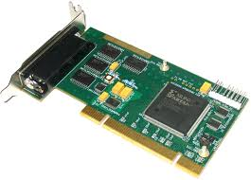

FIGURE 4: PCI

A Peripheral Component Interconnect (PCI) slot is a connecting apparatus for a 32-bit computer bus. These tools are built into the motherboards of computers and devices in order to allow for the addition of PCI devices like modems, network hardware or sound and video cards.

PCI requirements include:

* Bus timing
* Physical size (determined by the wiring and spacing of the circuit board)
* Electrical features
* Protocols

Year created 2004
Created by â¢Intel
â¢Dell
â¢HP
â¢IBM
Supersedes â¢AGP
â¢PCI
â¢PCI-X
Width in bits 1â32
Number of devices One de...

FIGURE 5: BLOCK DIAGRAM OF PCI

**CHARACTERISTICS:**

* Singling Environment : Support both 3.3 and 5 volt signaling environments.
* Reliability: It offers the ability to replace modules without disturbing a system’s operation called as hot plug and hot swap.
* Speed: It can transfer up to 132 MB per second.
* Configurability : The ability to configure a system automatically means automatically identify the interfacing systems and assigns new addresses.
* Synchronous bus architecture : PCI is a synchronous bus where data transfer takes place according to a system clock.
* 32 and 64 bit addressing : The PCI bus also supports 64 bit addressing with the same 32 bit connector.
* Large bandwidth : It can handle both 32 bit as well as 64 bit data hence the maximum bandwidth will be 132 MB per second.
* **ADVANTAGES:**
* Very high speed.
* Plug & Play.
* Dominant board-level bus
* **DISADVANTAGES:**
* Incompatible with older systems
* Can cost more

USB(UNIVERSAL SERIAL BUS) :

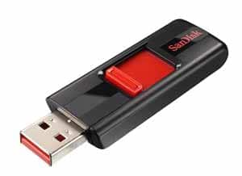

FIGURE 6: USB

USB ,Short for Universal Serial Bus, an external bus standard that supports data transfer rates of 12 Mbps. A single USB port can be used to connect up to 127 peripheral devices, such as mice,modems, and keyboards. USB also supports Plug-and-Play installation and hot plugging.Starting in 1996, a few computer manufacturers started including USB support in their new machines. It wasn't until the release of the best-selling iMac in 1998 that USB became widespread. It is expected to completely replace serial and parallel ports. USB(Universal Serial Bus)

FIREWIRE
â¢ FireWire is a method of transferring information between digital
devices, especially audio and video equipment....

FIGURE 7: PIN DIAGRAM OF USB

**CHARACTERISTICS:**

* A maximum 127 peripherals can be connected to a single universal serial bus (USB) host controller.
* USB can draw power by its own supply or from a computer. USB devices use power up to 5 voltages and deliver up to up to 500 mA.
* USB devices are hot swappable due to this we do not have to turn off, on or restart our computer when connecting or disconnecting a USB device.
* Individual USB cables can run as long as 5 meters with hubs, devices can be up to 30 meters away from the host.
* The speed of USB for USB 1.0 is 12 Mb per second and for USB 2.0 is 480 Mb per second.
* Many of the USB devices can be put to sleep by the host computer when the computer enters into a power saving mode.
* A USB 2.0 cable has two wires for power i.e. +5 volts and ground and a twisted pair of wires to carry the data. The USB 3.0 standard which has four wires for data transmission.

**ADVANTAGES:**

* The [universal serial bus](http://www.polytechnichub.com/universal-serial-bus/)is easy to use.
* It has robust connector system.
* It has low cost.
* It has variety of connector types and size available.
* It has true plug and play nature.
* It has Low power consumption.
* Daisy chain up to 127 USB components / peripherals at the same time to one PC.
* Fits almost all devices that have a USB port.

**DISADVANTAGES:**

* It has limited capability and overall performance.
* Universal Serial Bus does not provide the broadcasting feature, only individual messages can be communicated between host and peripheral.
* The data transfer not as fast as some other systems.

**ARBITARATION TECHNIQUES:**

**Bus Arbitration** refers to the process by which the current bus master accesses and then leaves the control of the bus and passes it to the another bus requesting processor unit. The controller that has access to a bus at an instance is known as **Bus master**

There are two approaches to bus arbitration:

1. Centralized bus arbitration – A single bus arbiter performs the required arbitration.
2. Distributed bus arbitration – All devices participate in the selection of the next bus master.

**Methods of BUS Arbitration –**  
There are three bus arbitration methods:

**(i) Daisy Chaining method –**  
It is a centralized bus arbitration method. During any bus cycle, the bus master may be any device – the processor or any DMA controller unit, connected to the bus.

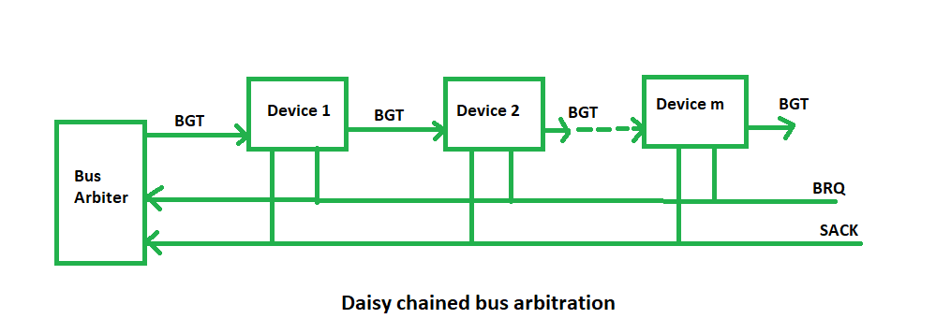

**Advantages –**

* Simplicity and Scalability.
* The user can add more devices anywhere along the chain, up to a certain maximum value.

**Disadvantages –**

* The value of priority assigned to a device is depends on the position of master bus.
* Propagation delay is arises in this method.
* If one device fails then entire system will stop working.

**(ii) Polling or Rotating Priority method –**  
In this method, the devices are assigned unique priorities and complete to access the bus, but the priorities are dynamically changed to give every device an opportunity to access the bus.

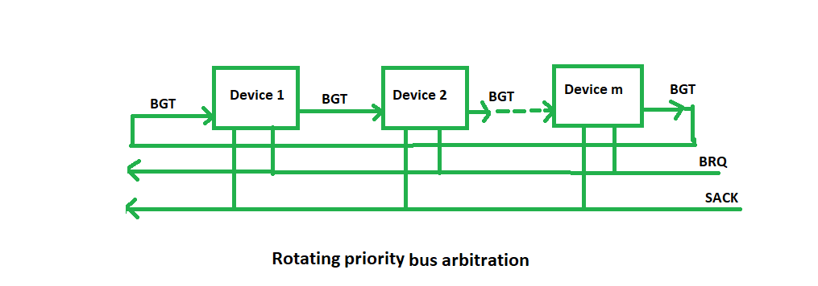

**Advantages –**

* This method does not favor any particular device and processor.
* The method is also quite simple.
* If one device fails then entire system will not stop working.

**Disadvantages –**

* Adding bus masters is different as increases the number of address lines of the circuit.

**CONCLUSION:**

From this experiment case study,we learnt about the system bus which are ISA ,PCI and USB.We learnt that in this era Usb are used more leaving ISA and PCI behind but still PCI is used as PCI Xpress for video and graphic cards.We learnt that how in different generations of system buses there was difference between clock speeds.